Ballinderry Parish News Sheet



Rector: Rev Trevor Cleland, 124 Ballinderry Road, Upper Ballinderry. Tel 028 9265 0134

Website: www.ballinderryparish.org. Like us on facebook – Ballinderry Parish Church. Follow us on Twitter - @ballinderryparish

March 2026
Dear Friends,

As we look around at our world today much will disturb us, and rightly so. The inhumanity of man is evident on our nightly TV news on a daily basis. Whether that be where we live in Northern Ireland in terms of how we live together, nationally, or in the personal lives that people live. People can be very cruel, and sometimes there is no other word to describe it than wicked.

Equally, the global situation is concerning too. As we write, the Ukraine war has been raging for four years with no sign of being brought to an end any time soon. America and Israel have attacked Iran, and Pakistan are attacking Afghanistan. This is the reality of the world: wars will happen, politicians argue, and innocent people suffer amid it all. The thing to say is, hope - the thing that is a common desire for all of humanity - seems to be the thing that is lacking.

Hope for the future is an important aspect to our lives; without it what is there to look forward to in life? And yet the reality is, if our hope is in people or the things of the world then we can be pretty sure that we are going to be disappointed. Real hope is a lasting hope, a sure and certain hope. It is this hope that we find in the Gospel and in the Easter story which is the very essence of the Gospel message.

In the Garden of Gethsemane on the night Jesus was arrested, he had to chastise Peter for using his sword to defend his friend and master. It was the worldly thing to do because in his confusion Peter got it wrong. Jesus said to him, “put your sword away, for those who take the sword will perish by the sword.” In other words, Jesus’ mission to bring hope to the world was not to be achieved using violence. No, the purpose of his mission was to be a sacrifice, not just for the benefit of the disciples, or even a local region of the world; but rather the hope that Jesus won was for the whole world in a way that was unimaginable at the time. It is a hope that lasts throughout all the generations - including us today.

As we have said, worldly hope is fragile and often it fails to deliver, but the hope of the Gospel is based the certain fact that Jesus died on a cross at Calvary and rose again on the third day and that because he lives, we also have life beyond the grave because of the victory He has won over sin and death.
The promise that Jesus gives us is spelt out in John 6 v 40, it is simply this; “….everyone who looks to the Son and believes in him shall have eternal life, and I will raise him up at the last day”.

Unlike the world around us, Jesus is the one who can truly deliver on his promises, because his promises are based not on human desire or human will, but rather on the purpose and plan of God. Jesus lived his life faithfully under the will of God; and so with a single-minded purpose, Matthew 20 v 18-19 tells us Jesus set his face towards Jerusalem where he was to be “betrayed to the chief priests and the teachers of the law. They will condemn him to death and will turn him over to the Gentiles to be mocked and flogged and crucified. On the third day he will be raised to life!”

Our hope for the people of Ballinderry and beyond is that they would know the hope of the Gospel in their lives this Easter. Therefore, can we take the opportunity to invite you to come along to our services over the Easter period, the details of which can be found below.

We would love to see you.
Yours in Christ,
Trevor Cleland

Easter in Ballinderry

Holy Week prayer meetings, Monday, Tuesday and Thursday, in the hall at 7.45pm

Good Friday Service in the Middle Church @ 7.45pm

Saturday 4th April Family Fun event, see advert for details

Easter Sunday: Dawn Service @ 6.30am in the church car park

Guest Service @ 10.30am, followed by shortened Holy Communion service

Annual General Vestry Meeting
The Annual General Vestry meeting will be held on Wednesday 22nd April at 7.45pm dv. This is a triennial year, meaning that not just the church wardens and Select Vestry will be elected, but also parochial nominators and synodspeople. This is an important event in the parish’s calendar, as it is your opportunity to hear the accounts presented and cast your vote in the nominations above. Everyone is free to attend the meeting, and if you are over 18, pay in to the church in a recordable way, and have signed the register of vestry persons, you are eligible to vote at the meeting. Please show your support by coming along, you will be very welcome!





1st Ballinderry Company

Rainbows
Ballinderry Rainbows are currently working on the ‘Be Well/Feel Good’ theme which is about looking after themselves. The girls were also presented with certificates and badges for the ‘Know Myself’ award they completed last term and 9 girls achieved their Bronze Award and 3 girls achieved their Silver Award.

Girlguiding celebrated 100 years of Thinking Day on 22nd February and the theme this year was ‘Friendship’. We celebrated this on 19th February where the girls looked at the different types of uniforms that rainbows had worn over the years, played a game to find out what other rainbows liked to do the same as each other. They also made some friendship bracelets and swapped them with another rainbow. A fun night was had by all and it finished with some cake.

We also had a pamper night where the girls came in their PJ’s, dressing gowns and slippers. They had their nails painted, wore facemasks, had hand massages and made some fruit skewers. We will also be preparing to do some craft for Mother’s Day in the next couple of weeks.

Brownies
Brownies are progressing well through what has proved to be a very busy second term. We have completed Unit Meeting Activities (UMA) and Skill Builders which will count towards the ‘Know Myself’ and ‘Express Myself’ themes that we started in Term 1. These activities together with the many interest badges that our Brownies have been working on at home will contribute to Theme Awards and ultimately the Brownie Bronze, Silver and Gold Awards. (Bronze is attained when two Themes are completed, silver when four themes are completed and The Brownie Gold Award is achieved when all 6 themes are completed.)

The Brownies celebrated 100 years of World Thinking Day; they played games from Switzerland and India, two of our World Centres. Everyone received a special commemorative badge. The evening ended with a slice of delicious cake.
We are getting organised for our upcoming annual Brownie Pack Holiday, there is great excitement for this weekend which will take place at the end of May in Lorne Guide House.
Guides
Last term was a busy one as the Guides explored the ‘Take Action’ theme, completing skill builders and UMAs, earning the Thrifting badge, and trying out a range of new Girlguiding badges from Food Critic to Healthy Sleep. Our newest Guides completed their pre-promise activities and proudly made their Promise, while others continue progressing towards their Bronze and Silver Awards.
This term we’ve moved on to ‘Know Myself’ theme, working through skill builders, UMAs and interest badges including Aspirations, Human Rights, Guiding History and Personal Brand. The girls also celebrated the 100th World Thinking Day with activities focused on friendship, along with some well-deserved cake. Patrols: Lions, Pandas, Dolphins and Foxes, have been working brilliantly together.
We hope to round off the term with a unit outing before Easter.
Rangers
The girls who previously completed their Bronze and Silver Duke of Edinburgh’s Award are now starting their training towards their upcoming Silver and Gold expeditions, which will take place over the summer.
The girls are also working on the ‘Be Well’ and ‘Express Myself’ theme awards which include the interest badges ‘First Aid’ and ‘Communication’. They are hoping that the skills gained from these badges will support them in successfully completing their Duke of Edinburgh Awards.

Urgent: the CLB needs your help!

From September 2026 we need a new officer/leader to work with the Martins. This section of the CLB has thrived in recent years, and we are extremely grateful for the hard work and dedication of Alison Kavanagh who is retiring in June after many years of faithful service. We thank her for her faithful service, and wish her well for the future.

Equally though, we really want to see this work continue, but it cannot and will not without your help! Please contact Trevor at the earliest possible date after prayerful consideration, to express your interest in this vital part of our church ministry among boys.

Family Announcements

Burials

2 December 2025 Mary Elizabeth Jane Duncan, Lisburn Rd, Moira

10 January 2026 Dorothy Jane Beckett, Clontarriff Road, Ballinderry

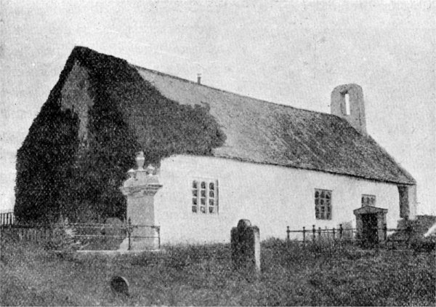
In compliance with General Data Protection Legislation, Ballinderry Parish has a policy in place relating to how we process, store and share your personal data. This policy can be read in full on our website at www.ballinderryparish.org, or you can request a paper copy from the Rector or Church Wardens

