A visit to Operation Rescue in Ethiopia
On Friday January 16th, 2026, we set off from Ballinderry to make our way to Makelle in Tigray, Northern Ethiopia. There were six of us in total and we travelled with two large cases each, hand luggage and ruck sacks. We brought gifts for sponsor children, clothes, wool, equipment for the ORE centres and much more. Our transfers went according to plan, and we arrived in Makelle on the Saturday morning after a long journey.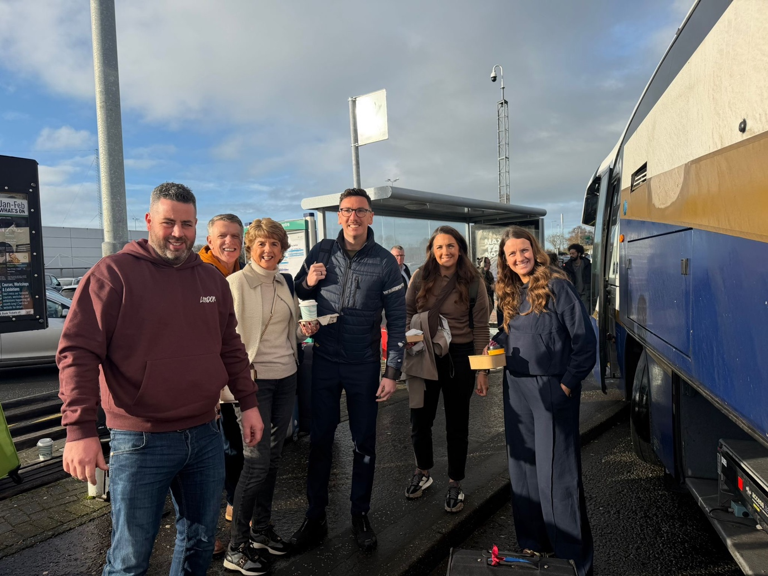

On Sunday I preached in Makane Yesus (The Place of Christ) and shortly after that we travelled north to the historic city of Axum. On the Monday morning, we had breakfast with a local pastor who leads a small congregation which comes under intense persecution. It was such a privilege to share with him and support the fellowship with a little money to help sustain them.
On arrival at ORE in Adwa we were met with children and their families, hugely exited to greet us. We all had a wonderful day together and really enjoyed seeing old friends and sharing the Gospel. There are around 100 children currently attending ORE Adwa. We had the joy of distributing 50 Kilos of Teff to each family.
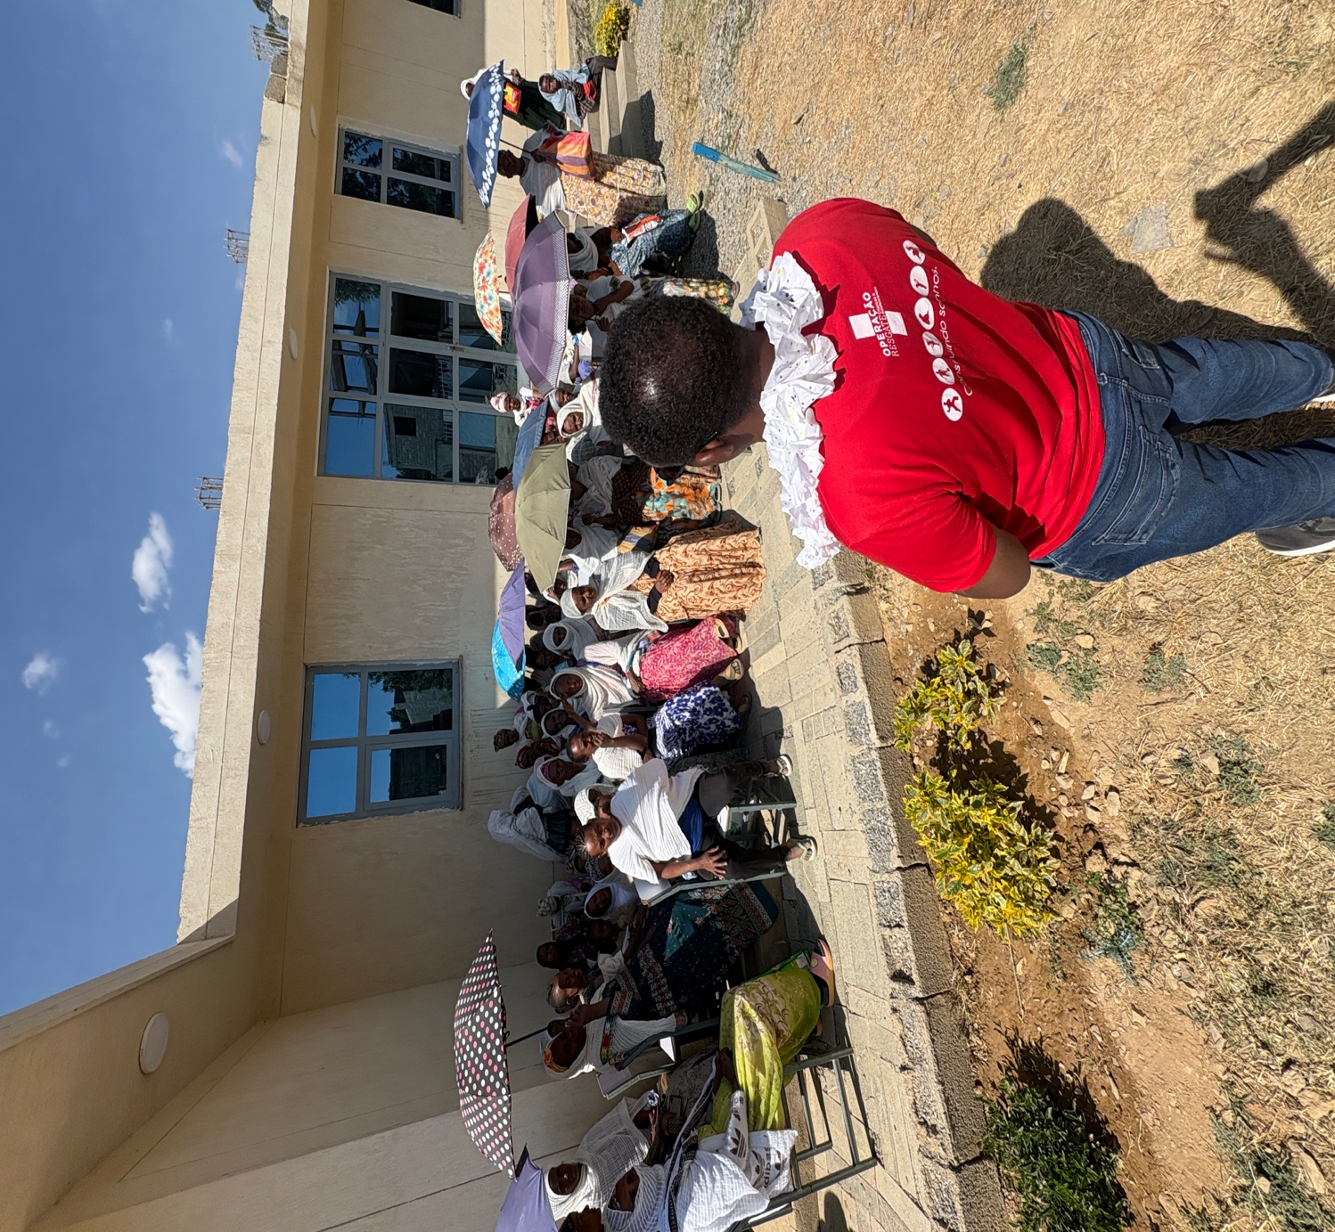

On Tuesday we visited ORE Adigrat and enjoyed the drama that the children had specially prepared. The depth of biblical knowledge the children had learned, was evident as we enjoyed bible quizzes together. Once again, we distributed we distributed 50 kilos of Teff to each family. The teff was purchased with the support from Northern Ireland. In total we were able over 30 tonnes of this staple grain. So many families expressed the gifts as an answer to prayer as we distributed practically while sharing the Good News of a Saviour.

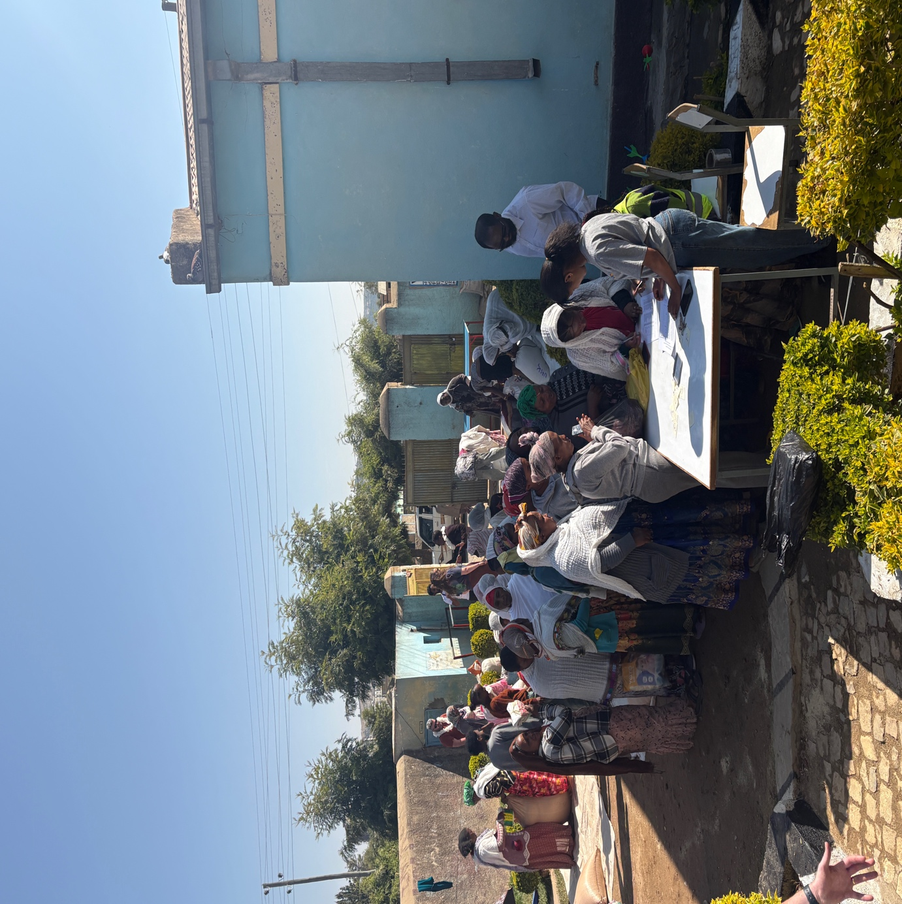

Wednesday and Thursday were spent in ORE Makelle. This is the largest centre and once again families had gathered to receive their teff. Our small team enjoyed taking devotion times with the children, teaching them crafting skills and other activities. Prayer time with the staff provided an opportunity for us all to pray for the ORE family and all it’s supporters. We really thank God how he is moving through this mission.
On Thursday evening we met up with a group of the teenage boys and over the two days special times were held with the older teenage girls.
There are currently over 110 children in ORE Makelle sponsored by supporters from N Ireland.
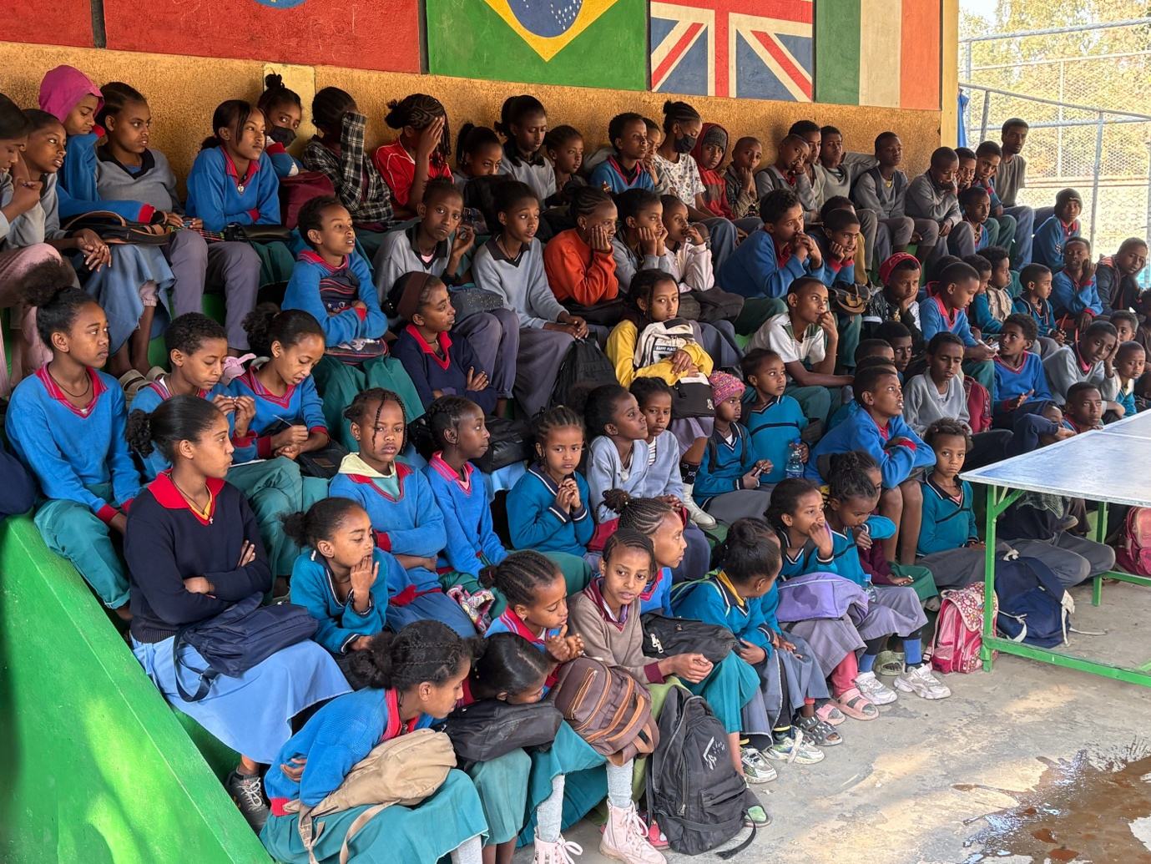
On Friday we had the joy of travelling to the city of Maichew and participated in the opening of an ORE centre which has been constructed with funds from N. Ireland. There was a large crowd and much excitement as we declared this new venture, officially open. There are 50 children now attending this centre daily. Dressing in the traditional clothes meant so much to the families. We even made the local TV News as the celebration created a lot of local interest.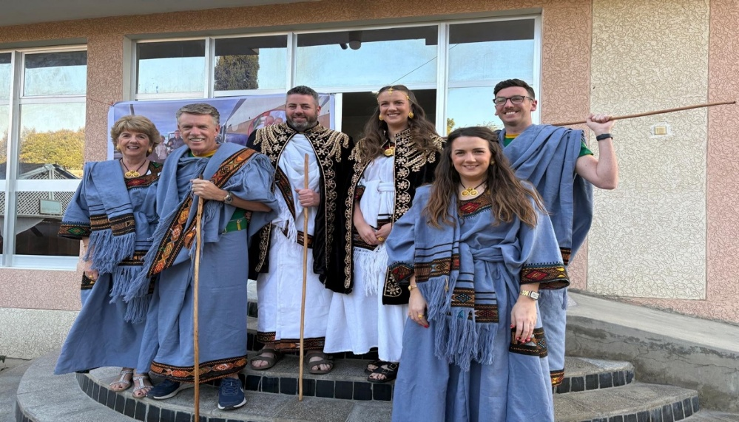t.

On return to Makelle, we spent the remaining time visiting sponsor children, assessing the need and trying our best to make a difference.
We give God the glory for all that was achieved and always count it a privilege to be involved.
Should you wish to contribute or would like to meet up to learn more please drop me an e mail or a message. I would be only too glad to provide more details.

Merville Boyd
E Mail: info@operationrescue.co.uk
Mobile: 078120 43994

